Taylor Cowley

Lab 02: CAD Schematic Entry and Simulation

April 28 2016

**Preparation**

Car alarm Schematic and simulation waveform

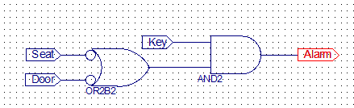

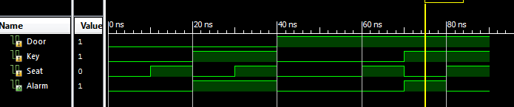

Minimize the following Boolean equation/circuit

1. 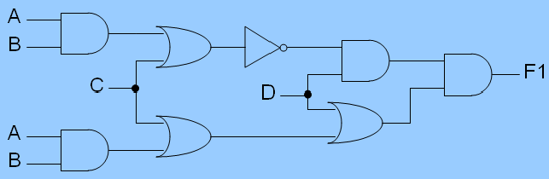

(AB+C)’*D*(D+(C+AB)) = F1

**(AB+C)’D**

1. (A + B + C)(A + C + D)(A' + B' + C')(A' + C' + D')

**AC’ + A’C + A’BD + B’CD’**

**Procedure**

1. Alarm fan schematic

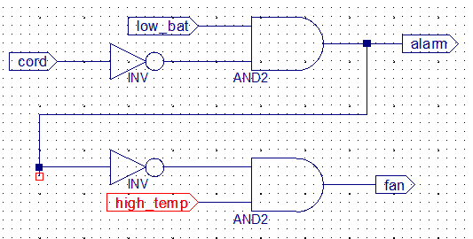

1. Alarm fan simulation waveform

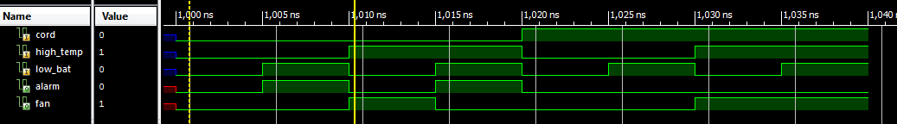

1. Problem 2.1 Original and simplified schematics

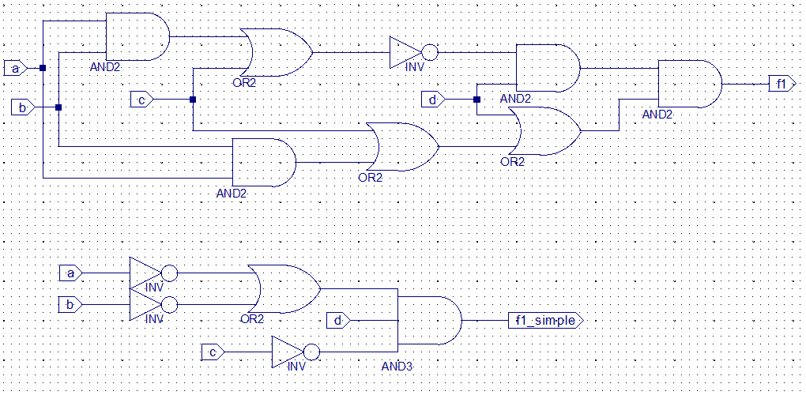

1. Problem 2.1 Original and simplified waveforms

Notice that both f1 and f1_simple have the exact same outputs.

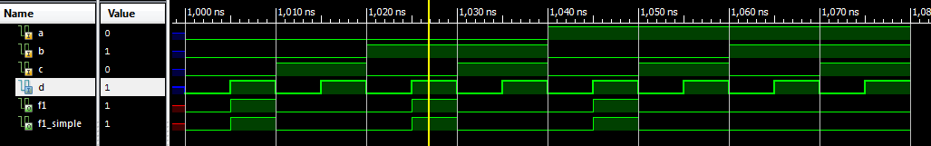

1. Problem 2.2 Original and simplified schematics

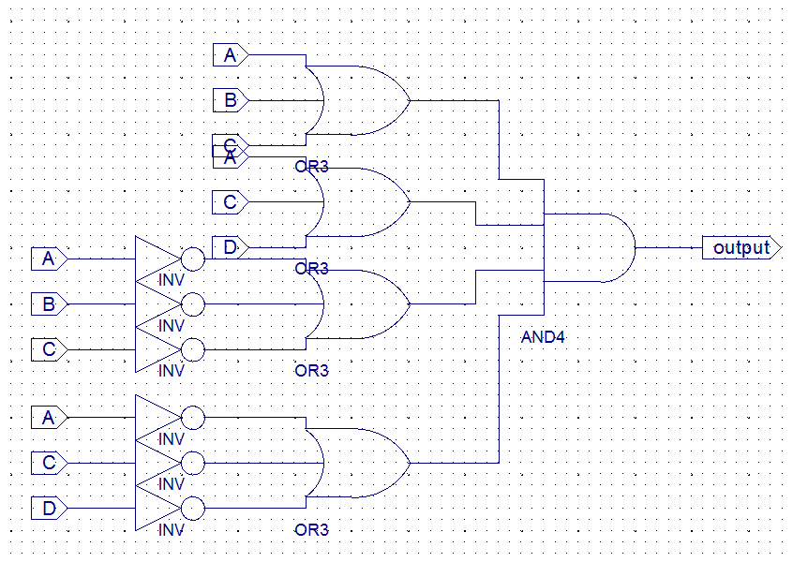 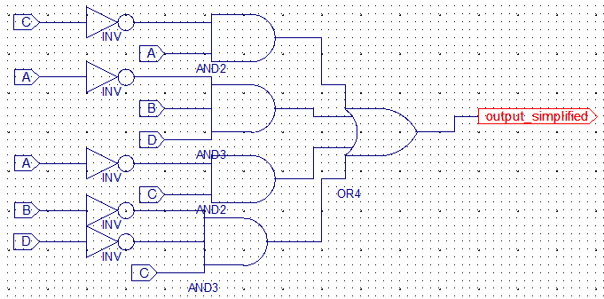

1. Problem 2.2 Original and simplified waveforms

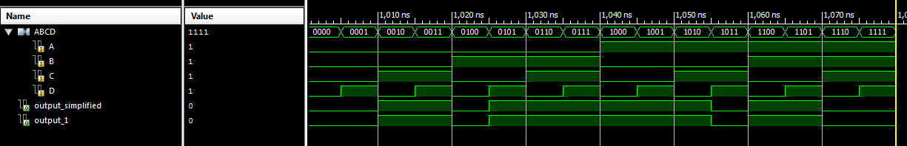

1. Truth tables and logic minimization work (4)

Problem 2.1

By inspection- the D anded with everything makes the second set of parentheses redundant. And so I got rid of everything inside

Problem 2.1 Problem 2.2

|  |  |  |  |  |
| --- | --- | --- | --- | --- |
| A | B | C | D | (AB+C)’D(AB+C+D) |
| 0 | 0 | 0 | 0 | 0 |
| 0 | 0 | 0 | 1 | 1 |
| 0 | 0 | 1 | 0 | 0 |
| 0 | 0 | 1 | 1 | 0 |
| 0 | 1 | 0 | 0 | 0 |
| 0 | 1 | 0 | 1 | 1 |
| 0 | 1 | 1 | 0 | 0 |
| 0 | 1 | 1 | 1 | 0 |
| 1 | 0 | 0 | 0 | 0 |
| 1 | 0 | 0 | 1 | 1 |
| 1 | 0 | 1 | 0 | 0 |
| 1 | 0 | 1 | 1 | 0 |
| 1 | 1 | 0 | 0 | 0 |
| 1 | 1 | 0 | 1 | 0 |
| 1 | 1 | 1 | 0 | 0 |
| 1 | 1 | 1 | 1 | 0 |

|  |  |  |  |  |
| --- | --- | --- | --- | --- |
| A | B | C | D | (A+B+C)(A+C+D)(A’+B’+C’)(A’+C’+D’) |
| 0 | 0 | 0 | 0 | 0 |
| 0 | 0 | 0 | 1 | 0 |
| 0 | 0 | 1 | 0 | 1 |
| 0 | 0 | 1 | 1 | 1 |
| 0 | 1 | 0 | 0 | 0 |
| 0 | 1 | 0 | 1 | 1 |
| 0 | 1 | 1 | 0 | 1 |
| 0 | 1 | 1 | 1 | 1 |
| 1 | 0 | 0 | 0 | 1 |
| 1 | 0 | 0 | 1 | 1 |
| 1 | 0 | 1 | 0 | 1 |
| 1 | 0 | 1 | 1 | 0 |
| 1 | 1 | 0 | 0 | 1 |
| 1 | 1 | 0 | 1 | 1 |
| 1 | 1 | 1 | 0 | 0 |
| 1 | 1 | 1 | 1 | 0 |

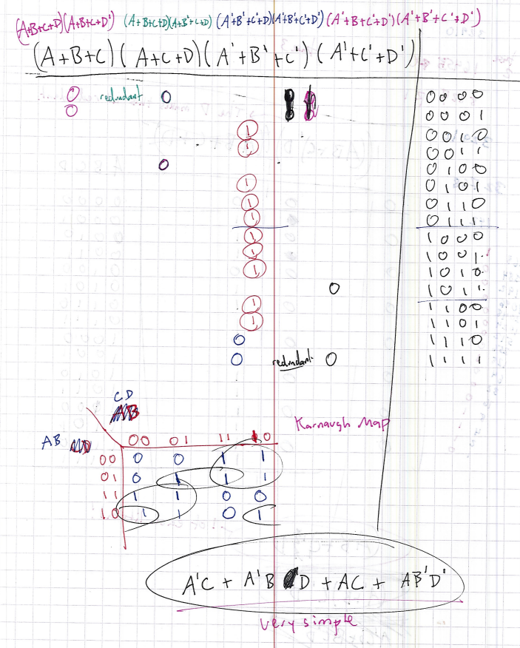

1. Anomalies

I had to look up online how to have 2 separate labels on the schematic actually be the same label (how to merge the nets) but other than that all was good ☺